CII Governance Plan

October 16, 2018

PREFACE

The Construction Industry Institute (CII) is an officially designated Organized Research Unit in the Cockrell School of Engineering at The University of Texas at Austin (UT-Austin). CII is a consortium of companies that rely on capital projects to generate business value. CII’s focus is on the practices required to plan and execute these projects. Its funding is derived from three sources:

- Unrestricted grants from member organizations in the capital projects industry
- Externally funded research grants
- Licensing of copyrights, patents, and software

Mission: The mission of CII is to provide a research and development platform to create and drive innovative solutions that tangibly improve business outcomes.

Vision: CII envisions an efficient capital projects industry that builds predictable value for member organizations, society and stakeholders. Leveraging new ideas, unique forms of collaboration, and knowledge across the project lifecycle, CII provides unmatched advocacy for the built environment.

The CII Governance Plan is intended to provide a general format and, when combined with the mission and vision statements above, to give direction that leads to the realization of the Institute’s vision. The plan relates to the Board of Advisors—its organization, functions, and activities. It is not intended to prescribe activities, operating procedures, or decisions that are the prerogative of the Executive Director and The University of Texas at Austin, or to preclude the Board of Advisors’ right to deviate from the plan.

MEMBERSHIP in the Institute is open to owner and service provider organizations that are committed to the safety and efficiency of the capital projects industry.

Institute membership, insofar as possible, reflects a diversified cross-section of the capital projects industry. Membership selection considers the prospective member’s classification, size, industry sector, and geographical areas of interest. Membership is balanced, to represent a broad view of the industry. Members may be owners (including government agencies), contractors (architects, engineers, designers, constructors, and suppliers), or service providers (consulting, financial, legal, or technology firms). An appropriate balance of influence between owner, contractor, and service provider members is maintained.

There will be three levels of membership:

- Large Companies whose annual revenues exceed $100,000,000 per year
- Small Companies whose annual revenues are $100,000,000 or less
- Breakthrough Companies who bring innovation to the capital projects industry and whose annual revenues are $20,000,000 or less. These companies will have specific, limited member privileges. Breakthrough Companies do not have a representative on the CII Board of Advisors (BOA).
As desired, program areas of the Institute may be extended to reach beyond member organizations to collaborate with selected individuals and groups within the capital projects industry.

CII ORGANIZATION
Figure 1 contains a diagram of the functional and reporting relationships among CII standing committees, sector committees, and staff roles in planning and executing the work of the Institute.

Figure 1. CII Organization

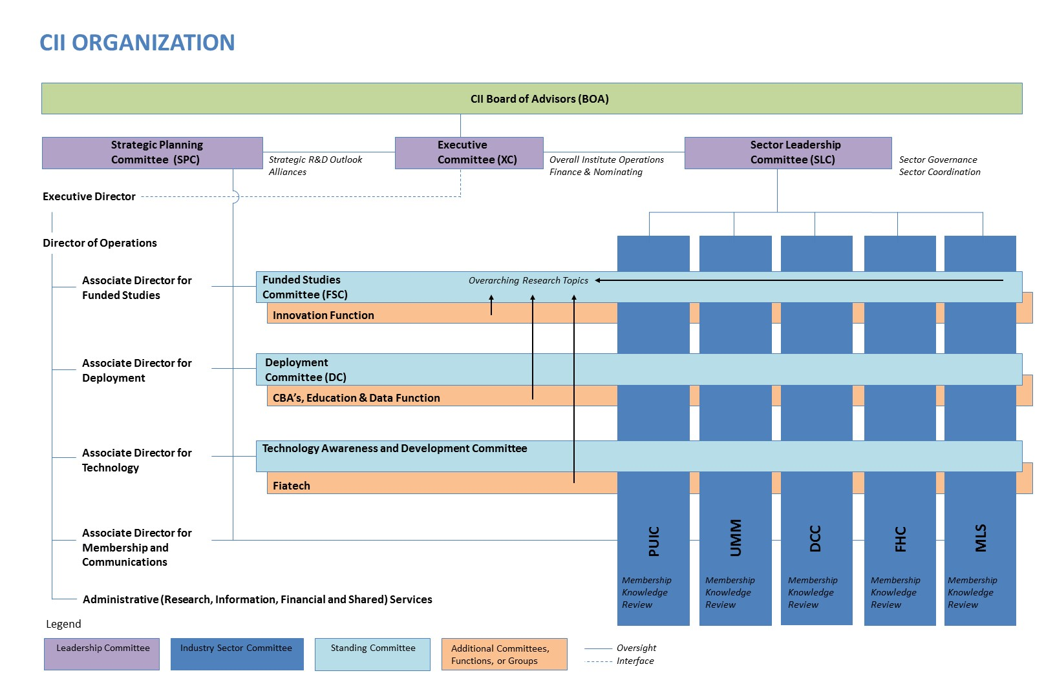3 | P a g e

The BOARD OF ADVISORS is responsible for all activities of the Institute. Each large or small member organization is limited to one vote, but entitled to designate one principal and one or more alternate representatives. Member representatives hold senior management responsibility, are involved in the capital projects processes and programs of their organizations, and are positioned to commit their organizational resources to CII activities. The Board of Advisors (BOA) meets in person at least once each year. Its Chair and Vice Chair (the CII Chair and CII Vice Chair) are elected by the membership from amongst the Executive Committee (XC) and also serve as Chair and Vice Chair of the XC. The BOA annually approves the Institute’s budget and elects the leadership of the Institute. All committee formation and dissolution is approved by the BOA.

The EXECUTIVE COMMITTEE, representing the BOA, provides leadership and direction for all Institute activities. The Executive Committee (XC) consists of 12 members (six owners, five service providers, and a non-voting Academic Advisor appointed by the Dean of the Cockrell School of Engineering at UT-Austin), including a chair and a vice chair. Candidates are elected by the BOA to serve three-year terms. To the extent possible, terms are rotating and staggered. Nominations for new XC members are received and approved by the XC. Membership to the Institute is approved by the XC by majority vote. The XC meets regularly, normally not less than six times per year. Meetings are held at the call of the CII Chair. The XC is also responsible for oversight of the finances of the Institute. This includes monitoring the income and expenses of the Institute, through the examination of staff-prepared budgets, funding of appropriate activities, and auditing of financial transactions.

The CII CHAIR is responsible to the BOA for the operation of CII in accordance with the Strategic Plan and the Governance Plan. To carry out these responsibilities, the Chair does the following:

- Provide leadership to assure mission accomplishment (see Preface)
- Chair all meetings of the XC and the BOA
- Consult with the Executive Director, as appropriate
- Create ad hoc committees when necessary

The CII Chair continues to serve as a member of the XC for the year following his or her term.

The CII VICE CHAIR assumes the responsibilities of the CII Chair in the Chair’s absence or when so requested by the Chair, the Executive Director, or the XC. The CII Vice Chair also performs such additional duties as are delegated by the Chair. The Vice Chair becomes Chair the year following, with the approval of the BOA.

The EXECUTIVE DIRECTOR provides strategic leadership of the Institute and, to the extent consistent with the law and The University of Texas at Austin policy and procedures, implements decisions made by the BOA and the XC. The Executive Director is responsible for interface directly with the Board of Advisors, the XC, and the SPC.

The Executive Director is responsible for recruiting, supervising, and directing the staff in performance of their duties and reports to the Dean of the Cockrell School of Engineering at The University of Texas at Austin.
The Executive Director, in coordination with CII’s Director of Operations and Associate Directors, is responsible for all functions related to the participation of academic personnel. Typically, the incorporation of academic personnel is through The University of Texas at Austin; however, participation includes academic institutions across the globe, consistent with CII’s international outreach initiatives.

The Executive Director is also responsible for planning and executing CII’s global outreach strategy in concert with the SPC and the Deployment Committee.

The CII DIRECTOR OF OPERATIONS, ASSOCIATE DIRECTORS and STAFF (described more fully below) perform duties assigned by the Executive Director.

The SECTOR LEADERSHIP COMMITTEE is comprised of current and prior leaders from each Sector Committee, the Director of Operations, an Academic Advisor, and additional at-large members from the BOA. The Sector Leadership Committee (SLC) provides guidance for the Sector Committees (sectors) and coordinates plans and actions across the sectors. The selection and arrangement of individual sectors may expand or contract to reflect CII’s membership, as determined by the SLC and approved by the XC and BOA. While the total budget allocated to CII’s sectors is approved by the BOA, the budget for each sector is allocated by the SLC in accordance with the Institute’s priorities. This distribution of budget to the sectors will be informed by the proportion of members participating in each sector.

The SLC approves sector-specific research and development requests from sectors and allocates funds approved by the XC and the BOA. The SLC may determine that a commonality of interest exists amongst several sectors and will aid the coordination of research and development efforts with the Funded Studies Committee. The SLC is responsible to the XC, for the guidance of sector research and development.

INDUSTRY SECTORS

The SECTOR COMMITTEES develop policy and programs related to their specific sectors of the capital projects industry. Each sector is administered by an assigned staff member. The Associate Directors rotate across the sectors on a regular basis at a frequency determined by the SLC to provide support from the standing committees and CBAs. Each sector has a Chair, Vice Chair, and an Academic Advisor to lead and conduct the business of the committee. The sectors are organized as follows:

- Power, Utilities, and Infrastructure
- Upstream, Midstream, and Mining
- Downstream and Chemicals
- Facilities and Healthcare
- Manufacturing and Life Sciences

Each sector is chartered to advance its business imperatives and conducts a limited number of initiatives at any given time. Each initiative represents a key business imperative for capital projects in that sector and includes a strategy for the deployment of findings with the intention to realize specific business outcomes. This may entail:
- Advocating for the development of products and services to optimize deployment of its findings
- Key performance indicators to aid deployment and use
- Demonstrations or case studies of early adoption, including lessons learned

Members of each sector collaborate with the AD for Membership and Communications to recruit new members and create campaigns that communicate and support committee initiatives.

Each sector annually reviews the CII Knowledge Base as assigned by the SLC to ensure the applicability and relevance of existing CII knowledge to its specific sector. Each sector may also further develop existing knowledge areas, tailoring them to better serve its members.

The STRATEGIC PLANNING COMMITTEE is comprised of prior leaders from each Standing Committee, the Executive Director, an Academic Advisor, and additional at-large members from the BOA. Members of the Strategic Planning Committee (SPC) serve three-year staggered terms. One of these members serves as the Strategic Planning Committee (SPC) Chair.

The SPC is responsible to the BOA, through the XC, for the development, evaluation, and update of the CII Strategic Plan and CII Governance Plan. The SPC also establishes performance measures and reports results annually to the BOA.

The SPC is responsible for identifying and developing Strategic Research and Development themes that increase the value received by Institute members. The SPC works closely with the Sector Leadership and Funded Studies Committees to maintain an awareness of relevant matters and priorities of the membership.

The SPC provides guidance to the Standing Committees. The SPC also provides guidance of the CII Communities for Business Advancement (CBAs), through the Deployment Committee.

CII DIRECTOR OF OPERATIONS, ASSOCIATE DIRECTORS AND STANDING COMMITTEES

The DIRECTOR OF OPERATIONS provides day-to-day operational leadership and manages ongoing activities of the Institute. The Director of Operations is responsible for the overall coordination of Sector Committees and Standing Committees, working with the Associate Directors and Staff. The Director of Operations supports the SLC and the XC to provide operational effectiveness and administration of the Institute.

The ASSOCIATE DIRECTOR FOR FUNDED STUDIES is responsible for administering funded studies, whether they are funded through member resources or external grants. The AD for Funded Studies is also responsible for the relationship with researchers, ensuring their work supports the capital projects industry.

CII operates as the research and development center for the capital projects industry. As such, the AD for Funded Studies is responsible for several key CII functions:

- Coordination of funding opportunities from research sponsors, which may include governments, industry, universities, and associations
- Allocation of financial and other resources to the pursuit of research topics
- Assurance that high academic rigor is maintained in all aspects of CII funded studies
- Oversight of assignments to research teams, ensuring that universities are appropriately represented in the delivery of funded research
- Maintaining academic relationships (supporting the Executive Director) with The University of Texas at Austin and other institutions of higher learning

The FUNDED STUDIES COMMITTEE is a standing committee responsible for planning and administering overarching funded studies on behalf of all members of the Institute. The fundamental intent of a CII funded study is to create and drive value to the business communities represented across CII’s membership. In this pursuit, the Funded Studies Committee (FSC) also works with the SLC and the sectors to assist in the planning and administration of sector-specific research activities. The FSC plans and orchestrates the creation of research teams as necessary and oversees research activities through to their successful completion.

The primary role of the FSC is the delivery of valuable, innovative research and development findings and content. The FSC works with selected Associate Directors and their designees regarding academic participation, to assign appropriate academic personnel to funded studies and to assure the high quality of research required of CII products and services. The FSC has a Chair, Vice Chair, and an Academic Advisor to lead and conduct the business of the committee.

The RESEARCH TEAMS are ad hoc groups composed of member representatives, one or more academics, and other support personnel assembled by the staff to study a research area approved by the BOA or a sector. Each research team (RT) is designed to conduct research on one or more specific project(s) assigned by the FSC or a sector in conjunction with the SLC. The general responsibilities of an RT include:
- Establishing value versus cost and timing early in the research, to confirm viability
- Guiding and providing data to the research effort. This may be coordinated with the sectors or the FSC.
- Ensuring completion of the research effort, including a report that evaluates the value of the research from an industry perspective. Where needed, this report may provide insights regarding the implementation of research findings, contribute ideas for educational efforts, and/or provide additional recommendations.

Individual RTs may call upon the entire resources of CII, its Associate Directors, standing committees, CBAs, and sectors, as needed for the successful completion of their work. Each RT will work with CII staff to ensure that the work it performs is of the highest quality and suitable for acceptance by the capital projects industry at large. Each RT aspires to develop innovations, rather than incremental improvements to existing practice.

RT funding is typically generated through member contributions or external research grants. Targeted and specific studies may also be funded by individual member or non-member entities affiliated with the capital projects industry.

The ASSOCIATE DIRECTOR FOR DEPLOYMENT is primarily responsible for assuring that member companies deploy CII’s research, products, and services in a manner that measurably improves their business performance. In this regard, this AD designs modes of implementation so that member improvement efforts will succeed. The AD for Deployment manages the Deployment Committee (DC), working with it to provide member support to the sectors.

The AD for Deployment oversees the Communities for Business Advancement (CBAs). Annually, the AD for Deployment assesses each CBA’s value versus cost of continuation, then recommends its continuation or dissolution to the SPC. The AD for Deployment makes recommendations to the SPC regarding CBA chartering, launch, and dissolution.

The AD for Deployment is responsible for the dissemination of CII’s research, products, and services among capital projects industry professionals. The Institute generates increased business value for its members through improved utilization of CII research, products, and services. The AD for Deployment uses traditional and non-traditional methods of distribution, including online education and social media, to increase the use of CII materials.

The AD for Deployment works with the Deployment Committee to bring state-of-the-art practices, training, and continuing education skills to the global capital projects community and coordinates implementation and educational events. The AD for Deployment also institutes policy and procedures, provides oversight, and recommends strategic approaches to CII’s collection, analysis, and dissemination of industry data.

The DEPLOYMENT COMMITTEE assures that members derive measurable business results from their deployment of CII research, products, and services. The Deployment Committee (DC) works with the AD for Deployment to design modes that deliver successful member improvement. The DC has a Chair, Vice Chair, and an Academic Advisor to lead and conduct the business of the committee.

The DC interfaces with CII member companies and sector initiatives to improve the dissemination of CII practices, tools, and resources. This includes:

- Assisting member companies to deploy CII’s research, products, and services in a manner that measurably improves their business performance
- Bringing state-of-the-art work process improvement and continuing education practices to the capital projects community
- Coordinating CII and sector implementation and educational events
- Instituting policy and procedures, providing guidance, and recommending strategic approaches to CII’s collection, analysis, and dissemination of data to demonstrate the value of implementing CII practices to member companies and the industry

The DC is responsible for assuring the business impact of CII research, products, and services across the capital projects industry. It works to establish CII’s value to member businesses through the measurement and assessment of capital projects planning and execution practices.

COMMUNITIES FOR BUSINESS ADVANCEMENT promote collaboration on current problems through productive inquiry and enhance the speed of knowledge sharing and transfer among CII members. CBAs produce research topics and programs for consideration by CII for overarching initiatives or directed to selected committees as necessary. The CBAs will also be responsible for delivering business solutions into the membership based on project initiatives they have undertaken. Each CBA has a Chair, Vice Chair, and an Academic Advisor to lead and conduct the business of the community.

The ASSOCIATE DIRECTOR FOR TECHNOLOGY is responsible for seeking out existing and emerging technologies across a broad range of industries which will drive productivity and efficiency improvements for CII member companies. The AD for Technology develops relationships across sectors to gain access to the latest data on existing and emerging technologies and industry best practices. In addition, the AD for Technology role supports research and development projects that advance technology in support of CII member companies.

The AD for Technology provides functional support to the Technology and Awareness Development Committee (TADC), Fiatech, and sectors by evaluating member company needs and helping to match these needs with existing or emerging technologies.

The TECHNOLOGY AWARENESS AND DEVELOPMENT COMMITTEE is responsible for identifying and fostering adoption of known technologies for specific project application across the CII membership. The intent is to identify and aid development and deployment of technologies that increase productivity and efficiency across CII member companies. This may include: hardware, software, human advancements (such as behavioral or learning), mobile platforms, or combinations of technologies that may be useful to the industries served by CII.

The TADC supports the AD for Technology in the evaluation of CII member company needs. The TADC has a Chair, Vice Chair, and an Academic Advisor to lead and conduct the business of the committee.

FIATECH is responsible for identifying, monitoring and evaluating innovative, emerging technologies that can be developed and applied to capital projects to advance productivity. Fiatech provides technology thought leadership for the Institute and works closely with the TADC to support technology awareness and deployment. Fiatech supports the evaluation of emerging technologies to drive productivity and efficiency improvements.

The ASSOCIATE DIRECTOR FOR MEMBERSHIP AND COMMUNICATIONS is responsible for the following:

- Delivering marketing and communications expertise to CII’s initiatives, with a focus on retaining and expanding membership by increasing satisfaction with CII’s value to their businesses
- Communicating the value of CII research, products, and services to member companies for their capital projects, operations, and businesses
- Assisting and coordinating the sectors in their outreach initiatives and in recruiting new members to the Institute

The AD for Membership and Communications is a marketing and communications professional that brings expertise in internal and external communications, as well as the use of social media for the benefit of CII’s membership.

The AD for Membership and Communications works with the sectors to provide functional support to their marketing and communications needs with tools, information, and expertise applied to their initiatives.

The AD for Membership and Communications supports other committees and CII staff, to increase attendance at events and to assure the quality of delivery of information needed by the capital projects industry.

ADMINISTRATIVE SERVICES provides the administrative support required for conducting the work of CII, including accounting, office management, personnel management, contracts, procurement interface with The University of Texas at Austin and other entities working with CII, and other duties as required. Administrative Services supports membership activities related to CII business coordination and communications as managed by the Director of Operations, balanced to consider value for cost. Administrative Services is envisaged to include information services, financial services, and shared services.

PROCESS INDUSTRY PRACTICES is a consortium of companies, organized under the Institute inside the Cockrell School of Engineering at The University of Texas at Austin. Process Industry Practices (PIP) harmonizes its members companies’ internal standards for design, procurement, construction, and maintenance. PIP membership, funding, and governance are separate and apart from the Institute. PIP is managed by a Director who also serves as an Associate Director of CII.

The CENTER FOR CONSTRUCTION INDUSTRY STUDIES is a research center, organized under the Institute inside the Cockrell School of Engineering at The University of Texas at Austin. The Center for Construction Industry Studies (CCIS) exists to facilitate and administer externally funded research grants for faculty in The University of Texas at Austin’s Construction Engineering and Project Management (CEPM) program. CCIS is administered by a faculty member of the CEPM program and is governed in accordance with University of Texas at Austin rules for Organized Research Units (ORU). CCIS reports to the Dean of the Cockrell School of Engineering through the Institute.

ALLIANCES are established multilaterally when CII and one or more other organizations see such a commonality of interest that a formal, durable liaison relationship is useful. Alliances take several forms:

- Academic – where CII may form an alliance with one or more academic institutions
- Associations – where other cooperative entities form an alliance with CII
- Global organizations – where regions desire to build capability in CII respective industries for the purpose of facilitating commerce
- Industrial – where a group of companies combine for the purpose of facilitating specialized industry capabilities

The Executive Director, working in concert with the SPC and XC, recommends the establishment of alliances in accordance with guidelines of UT-Austin. Alliances are approved by the BOA.

