Membership Engagement Planning Guide

Membership Planning Work Sheet

Engagement | Membership cost | # of people chosen to participate | Travel cost
Annual Dues | Large member-$39,600  Small member- $19,800  *New members receive 50% off first year dues | Large member: minimum 4 people  Small member: minimum 2 people | Travel to CII HQ for in person on-boarding: optional but highly encouraged
Knowledge Base | Included in membership fee | Unlimited users
BOA Meeting  - Fall  - Spring | Registration Fee: $465 per person (meals covered in group sessions) | Minimum 1 person- required | Airfare  Hotel  Food
Annual Conference | Registration Fee: $1,595 per person (meals covered in group sessions) | Minimum 1 person- required  Also open to non-members. Can invite industry colleagues | Airfare  Hotel  Food
Sector Committee Participation  - DCC  - UMM  - FHC  - PUIC  - MLS | Registration included in membership fee | Minimum 1 person- required | Airfare  Hotel  Food
Research Team | Registration included in membership fee | Minimum 1 person (not required but highly encouraged) | Airfare, Hotel and Food may be required depending on location of meetings
Professional Development  - Online Ed  - Attend courses | Organization subscription- $995 per year.  Online courses prices vary depending on subject matter | Unlimited users
CII’s Executive Leadership Program | Program costs $20,900 per attendee | Multiple participants annually | Airfare, some meals
Performance Assessment  - Submit project into 10-10 system  - General benchmarking programs  - Specialty programs  - Healthcare Benchmarking  - Pharma | Included in membership fee | Unlimited Users
Standing Committees and Communities of Practice (COP) | Registration included in membership fee | Four different committees and COP’s created for your participation. | Travel requirements vary among committees

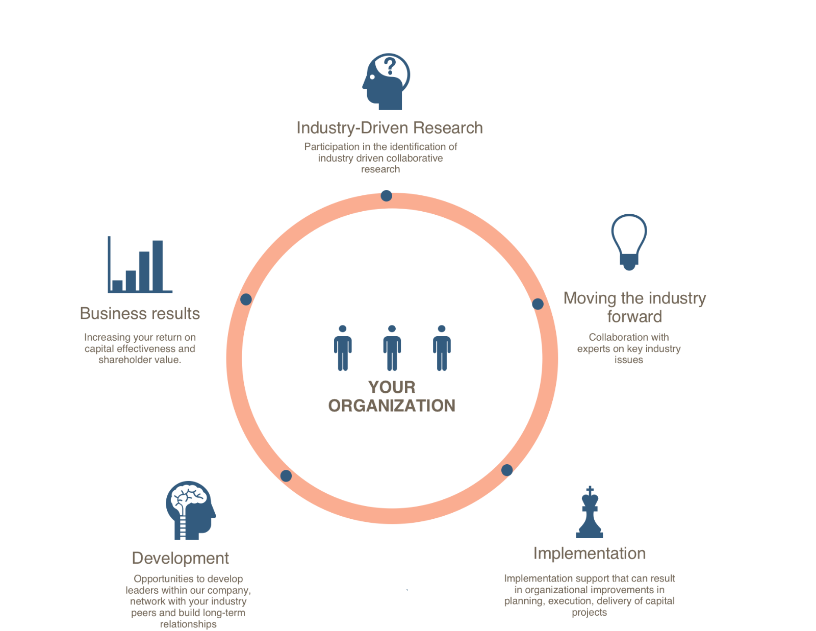

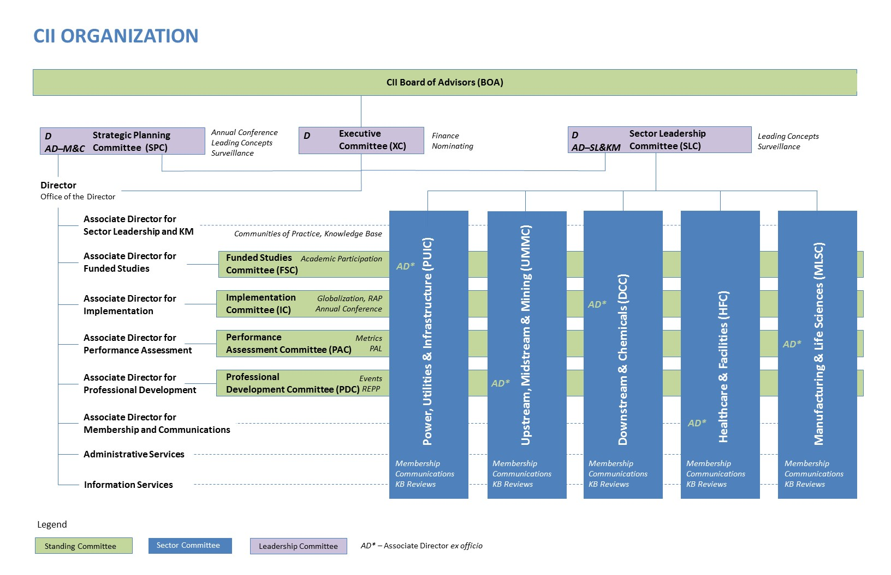

Industry Sector Key

CII organizes members among 5 industry sectors. The sectors allow for improvement in the uptake and implementation of CII research, designing custom industry solutions, addressing unique sector opportunities and the facilitation of deeper relationships among industry colleagues.

Organizations are allowed to participate in multiple sectors as reflected by the nature of your respective business.

Upstream, Midstream and Mining | Terminals, Off-shore, On-shore, Pipeline, Oil & Gas, Production
Manufacturing and Life Sciences | Pharmaceuticals, Auto-manufacturing, Food & Beverage, Agriculture, Pulp & Paper
Facilities and Healthcare | Government, Buildings, Healthcare Facilities
Downstream and Chemicals | Consumer Products, Refining, Specialty Chemicals, Industrial Chemicals
Power, Utilities and Infrastructure | Generation, Transmission, Road & Bridge, Transportation, Water & Waste

CII Organization Participation

CII exists to leverage your capital projects to produce distinctive business results for your organization. CII has various committees and roles for you to take gain the most value from your investment. It will be helpful to keep page CII’s organization chart (page 2) as a reference as your read the following opportunities of involvement.

Online Administrators – minimum of one (1) person – Required

Online Administrators provide CII web-based services access to others in your organization.

Commitment:
- Help people from your organization get logged onto the CII website for conference registration and/or publication downloads

Suggestions:
- Assign this role to a person who would like to learn more about CII and desires an opportunity for leadership
- Make this a two-year rotating assignment

Ideal candidate:
- Detail oriented
- Organized and reliable
- Strong communications skills
- Comfortable with technology

Next steps:
- Select an online administrator from your organization
  - Submit your candidates to Jenny Bien at jenny.bien@cii.utexas.edu

Board of Advisors (BOA) – minimum two (2) people – Required

The Board of Advisors (BOA) is the governing body of the Institute, responsible for all significant policy and operational decisions including funding and staffing of research projects. Each member organization is represented on the CII Board of Advisors by an advisor (primary representative) and one or more alternates.

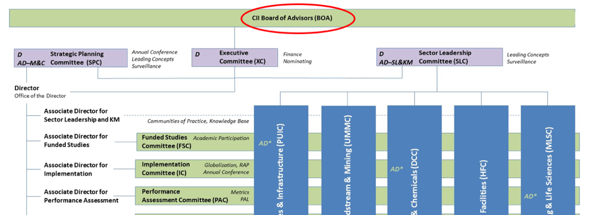

- Board members should have the organizational authority to take a leadership role in the development of a CII participation agenda. This includes the development and execution of an implementation strategy and authority to influence organizational change.
- Board members nominate personnel from their organizations to participate on CII committees and teams, thus they need to understand the availability of people from their organizations.

Travel Commitment:
- Spring BOA Meeting
- Fall BOA Meeting
- Annual Conference

Goals for the year:
- The development and execution of the implementation plan
- Influence organizational change

Ideal candidate:
- Proven leadership capability
- Influencer
- Strong communication skills and comfortable with virtual meetings
- Willingness to contribute, participate and provide ideas and feedback on initiatives
- Ability to travel to in-person meetings

Next steps:
- Select a primary representative from your organization
- Select an alternate representative from your organization
  - Submit your candidates to Jenny Bien: jenny.bien@cii.utexas.edu

Sector Leadership Committee (SLC) – (nomination only)

The Sector Leadership Committee provides oversight, communications, and coordination across the individual industry sectors to ensure their activities- particularly research selection and usage is: rationalized, prioritized, and resourced appropriately for fully developed and finished (“fully formed”) deliverables. The SLC’s primary scope is the prioritization of research use and allocation of resources to individual sectors to achieve its stated purpose. In this effort, the SLC works with the Executive Committee and the industry sector CII Associate Director to rationalize the distribution of funds.

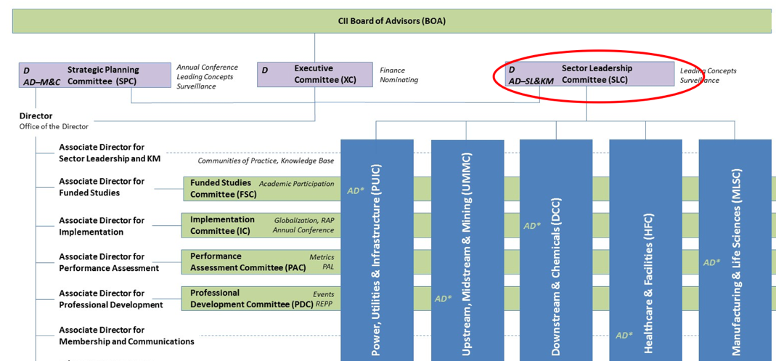

Goals for the year:
- Surveys the industry’s landscape to maintain awareness of leading concepts for consideration by the individual sectors in research selection.
- Provides communication and coordination among the sectors so that their activities are known and shared across sectors

Ideal candidate:
- Passionate about managing industry sector research initiatives
- Ability to be a resource for industry sector committee
- Strong communication skills and comfortable with virtual meetings
- Willingness to contribute, participate and provide ideas and feedback on initiatives
- Proven leadership capability
- Ability to travel to in-person meetings

Executive Committee (XC) – not applicable until 1 year of service on the BOA (nomination only)

The Executive Committee provides leadership for all CII activities. Its eleven members (six owners and five contractors) are elected by the Board of Advisors. The chairman and vice chairman represent owner and service provider membership and serve one-year terms. When the chairman is from the owner segment, the vice chairman represents the service provider membership, and vice versa.

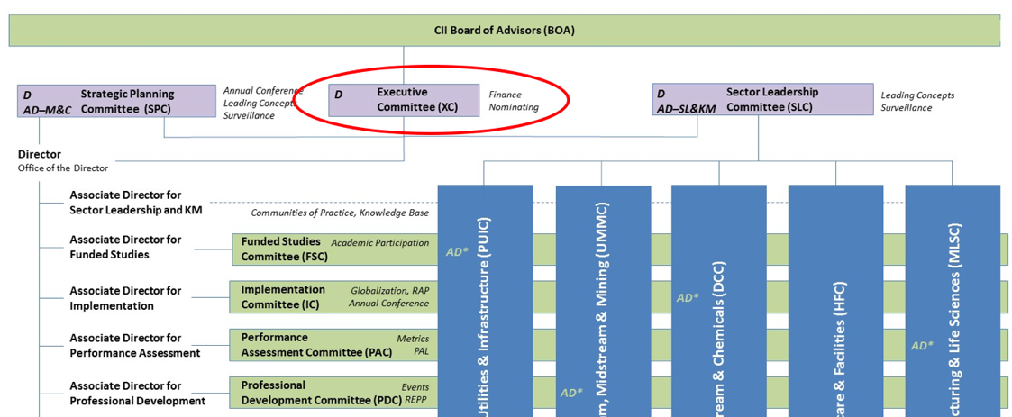

Strategic Planning Committee (SPC) – not applicable until 1 year of service on the BOA (nomination only)

The Strategic Planning Committee is responsible to the Board of Advisors, through the Executive Committee, for the development, evaluation, and update of the CII Strategic Plan, which is written with a three-year life cycle. The committee monitors industry trends and business drivers and updates the Strategic Plan. The Strategic Planning Committee establishes performance measures and reports results to the Board of Advisors annually. The Strategic Planning Committee (SPC) normally consists of the CII Chairman, Vice Chairman, the two immediate past Chairmen, the CII Director, and five at-large members from the Board of Advisors elected to three-year staggered terms (one to be SPC Chair).
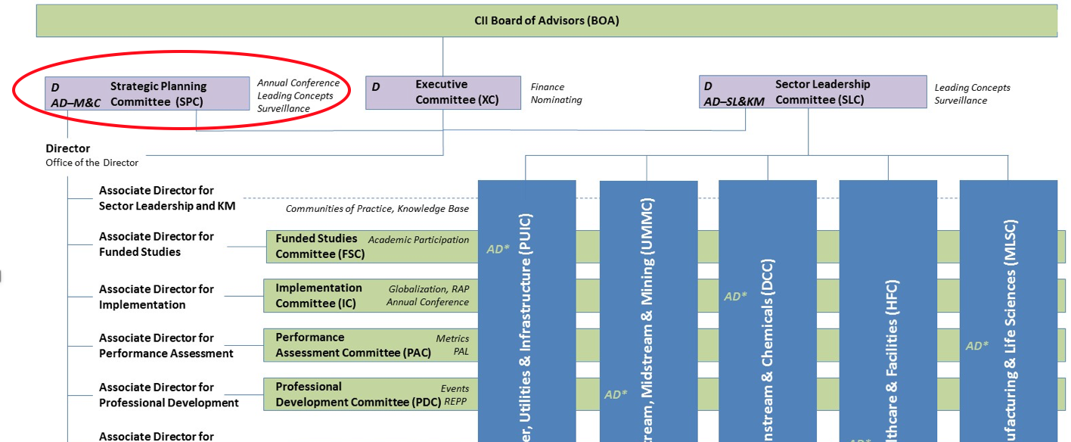

Funded Studies Committee (FSC) - optional

The Funded Studies Committee oversees CII’s research effort. The goal of this committee is to combine credible, quantitative, university-based research with industry expertise. This unique combination results in world-class research and contributes to establishing CII as the principal forum for the engineering and capital projects industry.

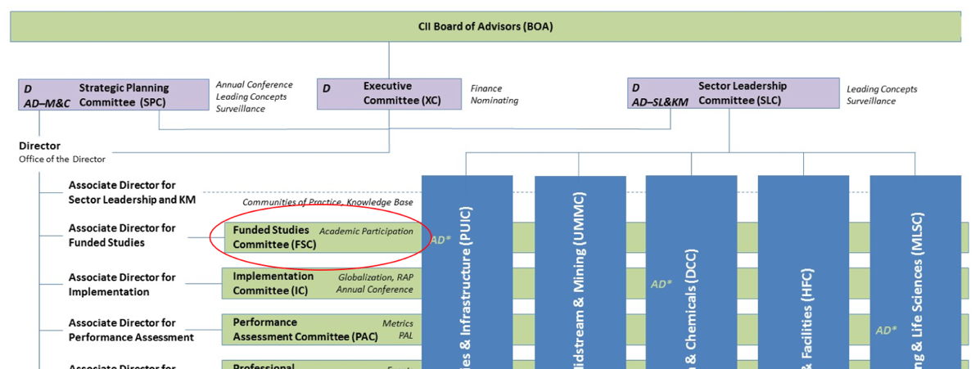

Goals for the year:
- Provide policy to guide and continuously improve the CII Research Process
- Implement the topic generation and prioritizing process for the CII Board of Advisors
- Establish appropriate funding approach for topics selected
- Select proposals from the academic community to provide greatest value to CII
- Keep the Board of Advisors informed on CII research activities

Implementation Committee (IC) - optional

At CII, we want you to get the most value out of your membership, participation and research. The Implementation Committee serves to seek out or develop new and creative processes, procedures, tools, systems or other management techniques to promote and encourage the use of CII practices within member company organizations.

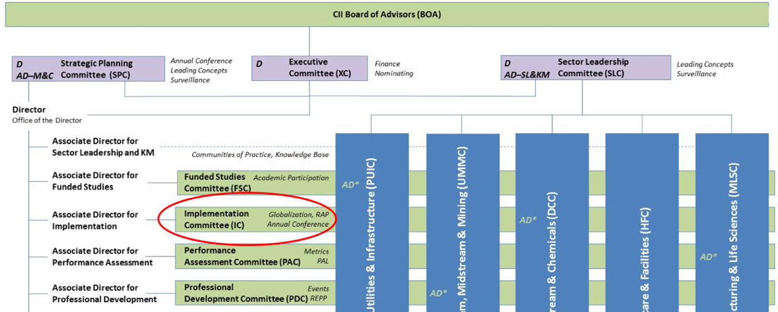

Goals for the year:
- Increase awareness of CII resources across CII member organizations
- Improve access to CII resources with self-directed "on-demand" options

Commitment:
- (3) face-to-face meetings and virtual meetings every other month

Performance Assessment Committee (PAC) - optional

The Performance Assessment Committee develops policy and procedures, provides oversight, and recommends a strategic approach to CII’s collection, analysis, and dissemination of industry data. The committee develops key definitions to guide the effort and identifies critical measurements needed for identification of best practices and management of a continuous improvement program. The committee interfaces with Benchmarking Associates, who are trained member organization representatives, for collection of data and interpretation and dissemination of benchmarking results.

There are various CII tools that you can utilize as member. Some examples include:
- Healthcare Benchmarking: http://www.healthcarebenchmarking.org
- 10-10 Program: https://www.construction-institute.org/benchmarking/10-10.cfm?section=pa
- Performance Assessment System: https://www.construction-institute.org/nextgen/index.cfm

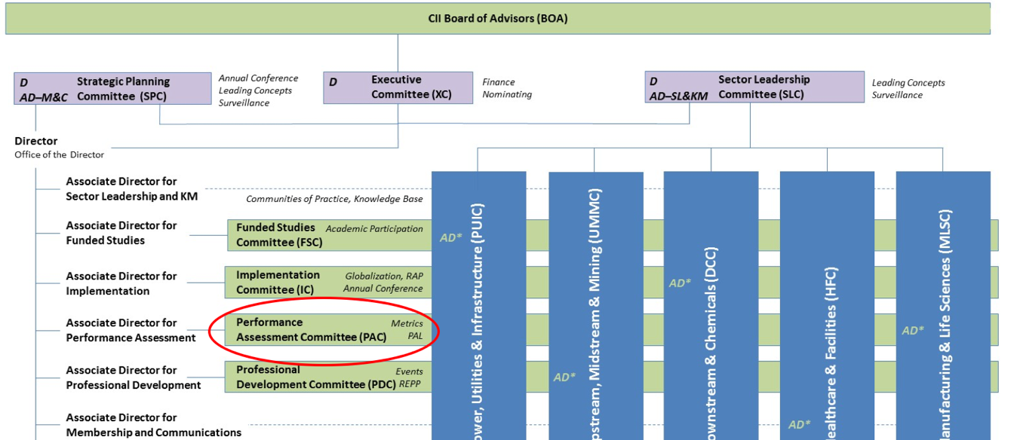

Commitment:
- (3) face-to-face meetings.
- Conference Calls for sub-committees

Professional Development Committee (PDC) - optional

The Professional Development Committee develops policy and programs related to the education function and maintains liaison with individuals, institutions, and organizations active in professional development. The committee identifies, evaluates, and implements changes in education delivery, chooses topics for new online education modules, and recommends creation of education teams, as required. The committee also performs periodic reviews of the education and the professional development needs of member organizations.

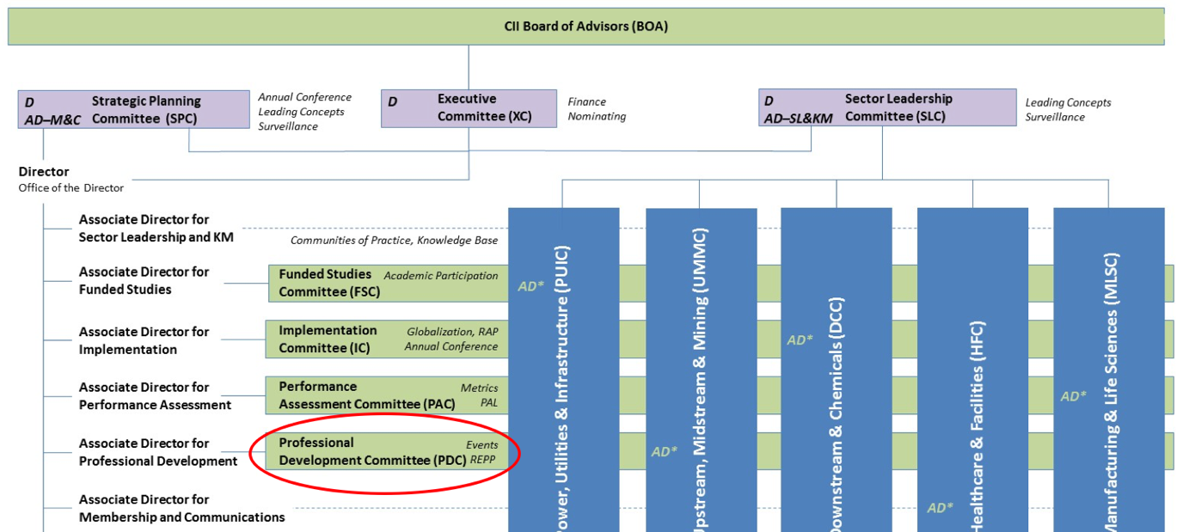

Goals for the year:
- Promoting and enabling implementation of CII research through educational-based programs, content and outreach.
- Providing input to ensure that CII’s strategic plan reflects professional development and learning trends within industry.
- Review of all new education products, both electronic and print, for content, quality and fit-for purpose to provide the necessary quality control information.

Commitment:
- (3) face-to-face meetings
- Participate in "ad hoc subcommittees," which are set up to accomplish a specific purpose or task

Research Teams

CII is your research and development department. Participation in a research team will enable your organization to solve problems within your industry alongside your peers, be on the fore-front of cutting edge concepts and spearhead innovative methods to produce radical returns on your investments in capital projects.

Commitment:
- Quarterly face-to-face and monthly conference calls
- Report findings at Annual Conference

How to join:
- Contact your Industry Sector’s CII Associate Director or the Funded Studies Committee, Mike Pappas, for more information

Community of Practice (COP)

CII continues to sponsor new venues to promote knowledge sharing and interchange among its members. These venues, Communities of Practice (COPs), have great potential to influence the course of knowledge management and future CII research.

There are various COP’s you can participate in as a member:

- Advanced Work Packaging
The Advanced Work Packaging COP (AWPCOP) is a formal venue for the exchange of advanced work packaging principles, practices, and related knowledge to enhance the performance of capital facilities projects. The goal of its members is to communicate principles, practices, and tools for successful implementation of advanced work packaging and related productivity practices through knowledge sharing and participation.
- Front End Planning
The Front End Planning Community of Practice (FEPCOP) is a formal venue for the exchange of knowledge relative to Front End Planning processes, procedures, tools and lessons learned for all types of capital projects – with a goal to ensure more effective implementation. The FEPCOP is composed of members who share a vision of Front End Planning as a best practice that facilitates improvement in the cost effectiveness of capital investments.
- Information Management
The Information Management Community of Practice (IMCOP) is a formal venue for the exchange of knowledge relative to the implementation of information management technologies and work processes to support the capital project delivery process. The IMCOP is composed of members that share a vision of improving the practice of information integration and related technologies.
- Modularization
The Modularization Community of Practice (MCOP) is composed of members that share a vision of guiding the capital projects industry to enhanced project performance through modularization. The goal of its members is to communicate principles, practices, and tools for successful implementation of modularization to the capital projects industry.
- Project Controls
The Project Controls Community of Practice (PCCOP) is composed of members that share a vision of Project Controls as a best practice to facilitate better project outcomes. The goal of its members is to help insure more effective implementation of Project Controls via knowledge sharing and exchange of current issues.
- Quality Management
The Quality Management Community of Practice (QMCOP) is composed of members that recognize and share a vision of Quality Management as a best practice to facilitate improved project outcomes and performance. The goal of its members is to help insure more effective implementation of Quality Management key principles via knowledge sharing and exchange of current issues.
- Risk Management
The Risk Management Community of Practice (RMCOP) is composed of members that share a vision of establishing Risk Management as a CII Best Practice. This COP will focus on knowledge sharing of current risk management practices and other risk management principles, practices, key success factors, and lessons learned to facilitate and promote wide-spread use among the CII membership.
- Safety
The Safety Community of Practice (SCOP) is composed of members that share a vision of an accident-free workplace through the leveraging of lessons learned and best practices. The goal of its members is to increase the overall safety performance of the construction industry. Information of particular interest will consist of items of interest to the industry that are yet to receive focused attention and problematic issues that have been faced by SCOP members. Current issues and emerging concerns will also be addressed by the SCOP.
- Supply Chain Management
The Supply Chain Management COP is composed of members that share a vision of guiding CII members to enhanced project performance through supply chain management and related procurement and materials management practices. The goal of its members is to communicate principles, practices, and tools for successful implementation of key supply chain management principles through knowledge sharing and participation.

How to join:
- Contact Kim Allen, Associate Director, Industry Sector Leadership, Sector Leadership Committee and Communities of Practice kallen@cii.utexas.edu

